DSA GROUP PROJECT

Phonebook Application.

|  |  |
| --- | --- |
| **Group Member** | **Student Number** |
| Lindiwe Hamalwa | 224082205 |
| Jesse Alfredo | 224081764 |
| Ndeshipanda Ndjekela | 224040448 |
| Aden Beukes | 221138072 |
| Manvelito Zaaruka | 224039571 |
| Reiter Nambinga | 224025694 |

Our phonebook application uses the **linked list data structure.** This data structure makes it easy to add and remove contacts. It also only uses memory when needed, making it efficient. This helps make searching for contacts fast and easy.

Phonebook application

Pseudocode

START

Prompt user for Name and contact number

Get Name and contact number

WHILE true DO

DISPLAY "Phonebook Menu:"

DISPLAY "1. Insert Contact"

DISPLAY "2. Search Contact"

DISPLAY "3. Display All Contacts"

DISPLAY "4. Delete Contact"

DISPLAY "5. Update Contact"

DISPLAY "6. Sort Contact"

DISPLAY "7. Exit"

Prompt user for choice

Get userChoice

IF (userChoice = 1) THEN

CALL insertContact()

ELSE IF (userChoice = 2) THEN

CALL searchContact()

ELSE IF (userChoice = 3) THEN

CALL displayContacts()

ELSE IF (userChoice = 4) THEN

CALL deleteContact()

ELSE IF (userChoice = 5) THEN

CALL updateContact()

ELSE IF (userChoice = 6) THEN

CALL sortContact()

ELSE IF (userChoice = 7) THEN

DISPLAY " Exiting phonebook"

ELSE

DISPLAY "Invalid choice, please try again."

END IF

ENDIF

ENDIF

ENDIF

ENDIF

END WHILE

END

insertContact(){

Prompt for name and contact number

Get name and contact number

IF (name and phoneNumber to hashTable

PRINT "Contact added."

END

}

searchContact(){

Prompt a name to search:"

Get searchName

IF (searchName is found in hashTable) THEN

DISPLAY "searchName and corresponding phone number"

ELSE

DISPLAY "Contact not found."

END IF

END

}

displayContacts(){

DISPLAY "Displaying all contacts:"

FOR EACH name in hashTable DO

PRINT name and corresponding phone number

END FOR

END

}

deleteContact(){

Prompt Name to delete

GET name

IF (name is found in hashTable) THEN

DISPLAY "Contact deleted."

ELSE

DISPLAY "Contact not found."

END IF

END

}

updateContact(){

Prompt for Name to update

GET name

IF (name is found in hashTable) THEN

DISPLAY "Contact found and updated:"

ELSE

DISPLAY "Contact not found."

END IF

END

}

sortContact(){

SORT contact list alphabetically

DISPLAY " Contacts sorted alphabetically"

END

}

END

Flowchart

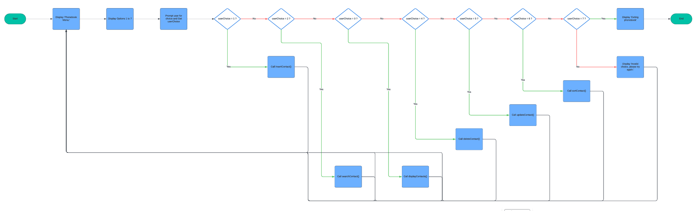

Adding a contact

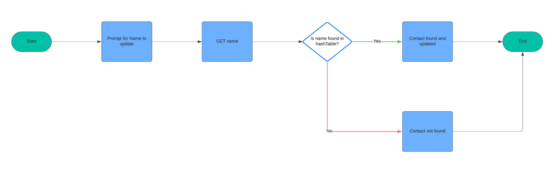

Searching for a contact

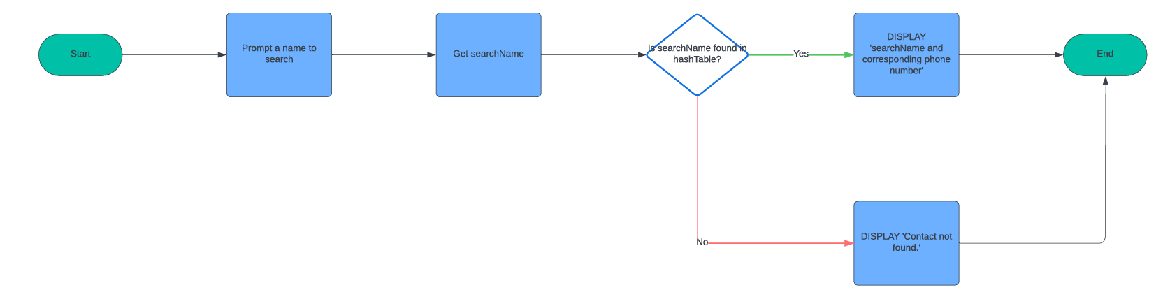

Displaying all contacts

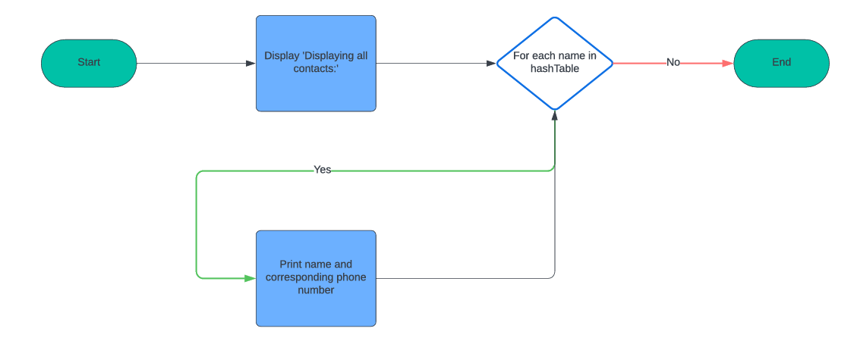

Deleting a contact

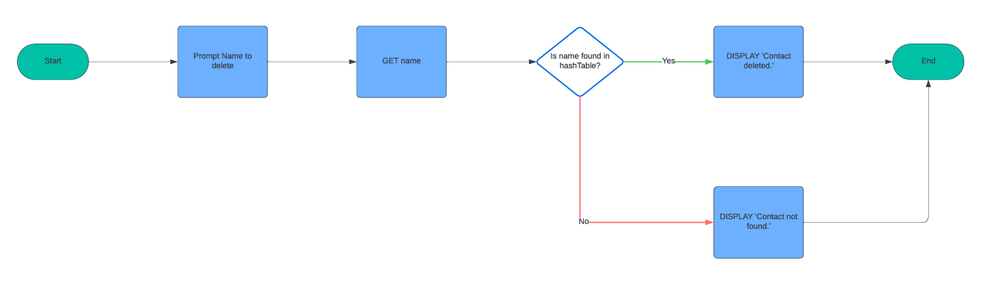

Updating a contact

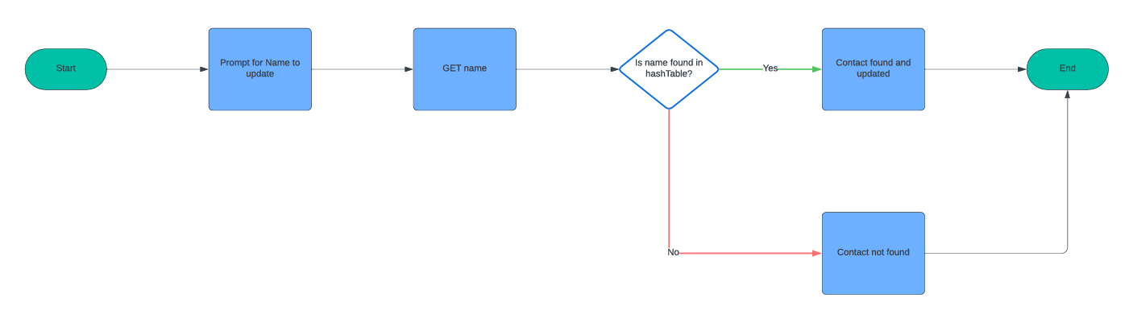

Sorting all contacts

Source Code & GUI

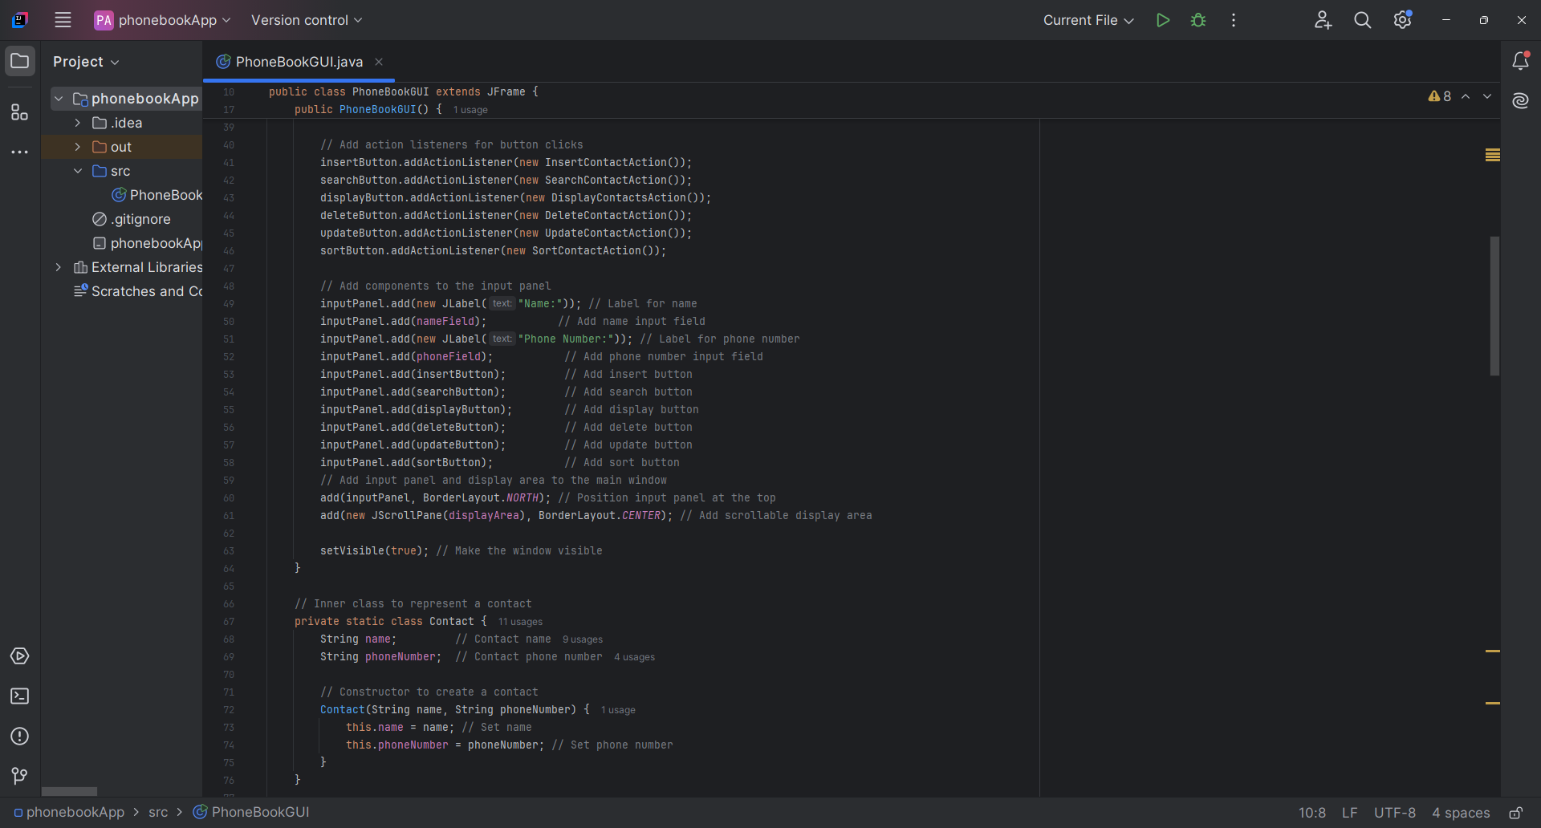

Screenshots of the application

Inserting a contact



Deleting a contact



Searching a contact

Updating a contact

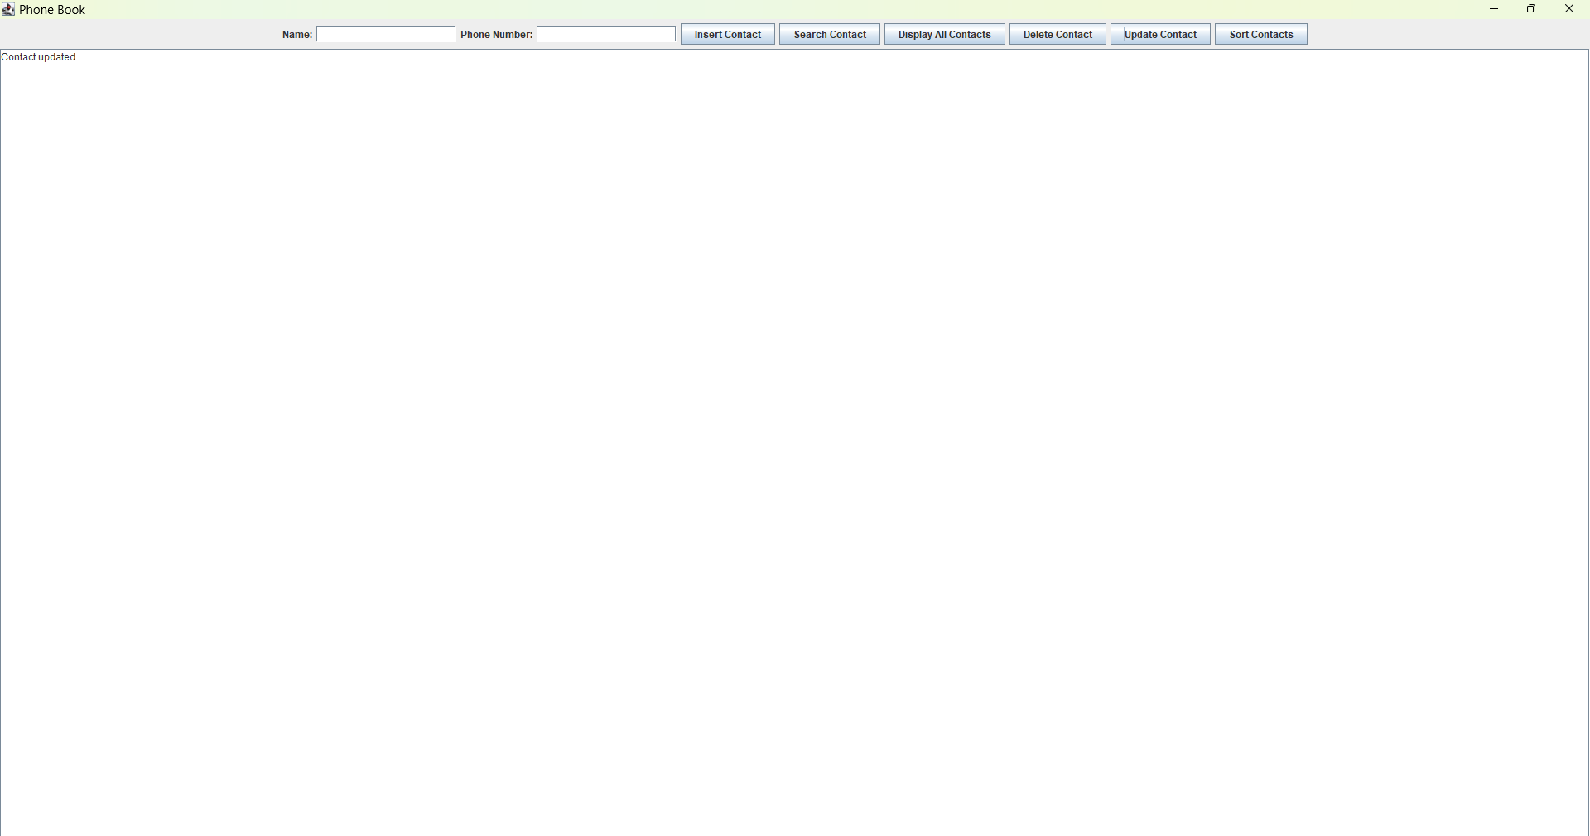

Sorting contacts

Displaying all contacts

